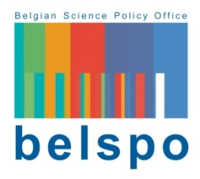
FEDERAL RESEARCH PROGRAMME ON DRUGS.

Federal Research Programme Drugs

INSTITUTION REQUEST FORM

If your research institution is not in the list of eligible partners on the submission platform, you can complete this Institution Request Form and send it to drugs_call@belspo.be. Only requests accompanied by the completed Institution Request Form and the necessary annexes will be evaluated.

To be eligible as a project partner and receiving BELSPO funding, your institution must demonstrate that it belongs to the non-profit sector and that its statutes clearly contain the pursuit of scientific research.

Name of the Institution:
Acronym of the Institution:
Legal form:
Name of the Director:
Contact person:

Full address:

Tel: |  | Email:

Website:

EVIDENCE OF SCIENTIFIC ACTIVITY

Refer here to the part of the articles of association of your organisation where scientific activities are mentioned. Annex the full articles of association to this Form.
Part of the articles of association where scientific research is mentioned:
Click here to enter text.
Describe and provide evidence of recent research activities and public grants eventually received:
Click here to enter text.

The State reserves the right to request additional information and/or evidence to complete the eligibility evaluation.

COMMITMENT

The undersigned, ........................, acting in the capacity of .................................... within the above-mentioned research institution, declares that this notification and the accompanying documents are true and sincere.

Drawn up in ........... on ........./......../..........

Signature:

